**DECORATIVE CONCRETE**

**FREQUENTLY ASKED QUESTIONS**

**HOW MUCH EXTRA WILL IT COST?**

**Decorative concrete costs approximately $6.00 to $10.00 per square foot more than regular concrete depending on the square footage of the project.**

**HOW LONG WILL IT LAST?**

**Decorative concrete lasts just as long as regular concrete, 25 years or more. Decorative concrete will need to be sealed every 3-5 years in order to maintain gloss.**

**WHY DO YOU CHOOSE TWO COLORS?**

**One color is the “base” color and the other color is there for color variation.**

**Just like natural stone and brick have variations, decorative concrete has color variations to make it look closer to the stone or brick which it resembles.**

**HOW IS THE WORK DONE?**

**If you would like to see how this work is done, we have a video in the main office.**

**WHAT TYPES OF APPLICATIONS CAN IT BE USED FOR?**

**Decorative concrete can be used almost anywhere. Many people use decorative concrete for patios, driveways, around pools, for steps, stoops, and sidewalks. Nearly any surface can utilize decorative concrete.**

**WHAT MAY I USE TO REMOVE SNOW AND ICE?**

**Unfortunately any chemical that will melt snow and ice creates another freeze thaw cycle for concrete which is the worst condition for your concrete of any type. Our recommendation is to simply shovel or plow your concrete immediately after a snowfall before any traffic compacts the snow, making it harder to remove. In the event that you are forced to use any kind of deicer it would be best if you cleaned the melted snow off as soon as possible before it has a chance to freeze again.**

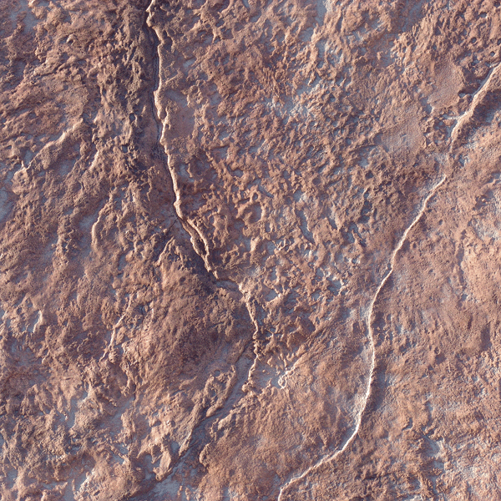

**Seamless Old Granite Cleft Stone**

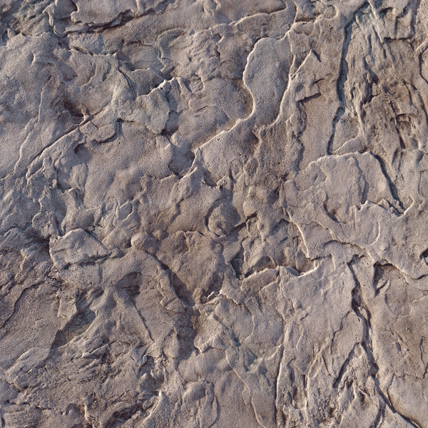

**Seamless Roman Slate**

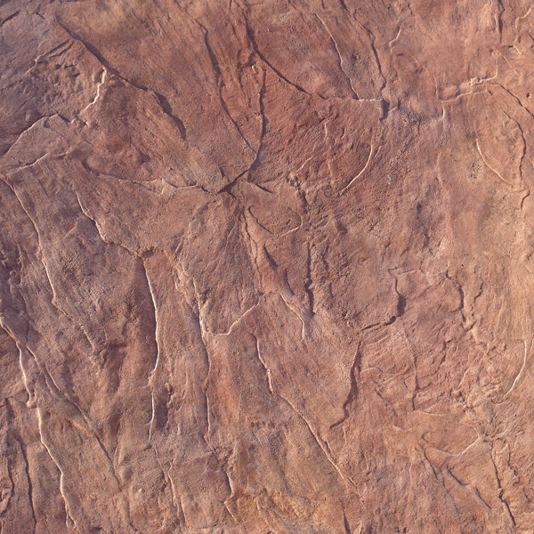

**Seamless Italian Slate**

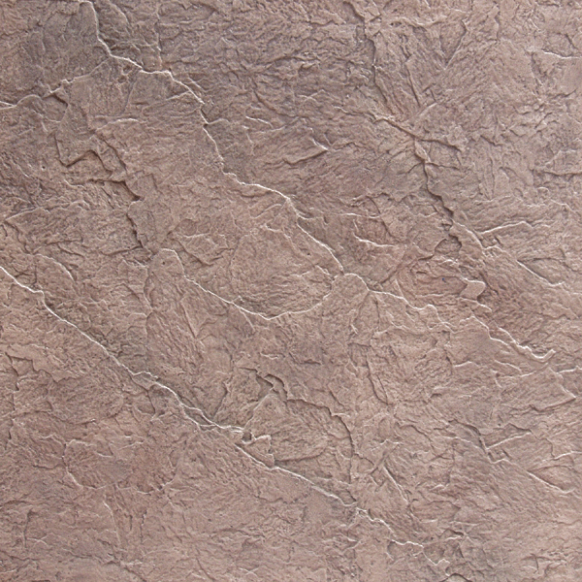

**Seamless Belgium Slate**

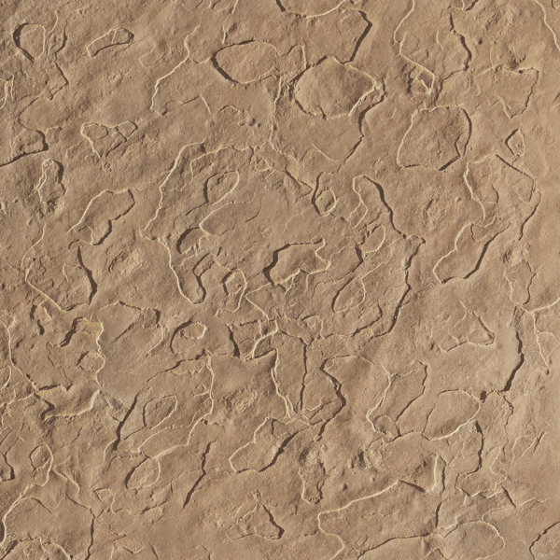

**Seamless Sandstone Light**

**Travertine Coarse**

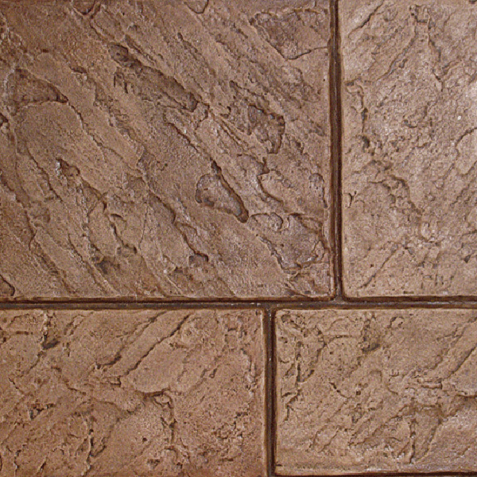

**Large Ashlar New England Slate**

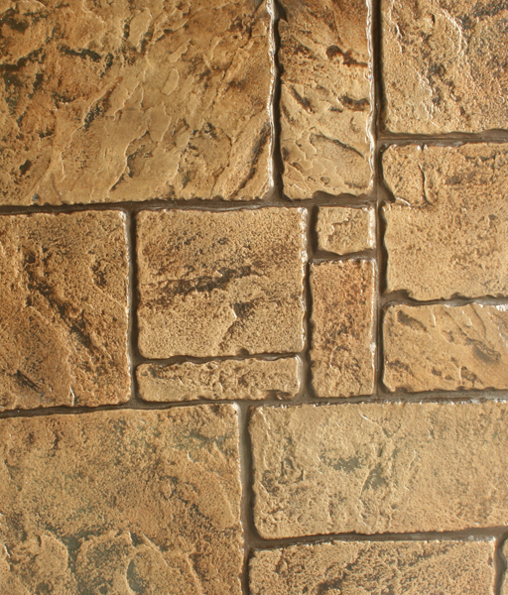

**English Ashlar**

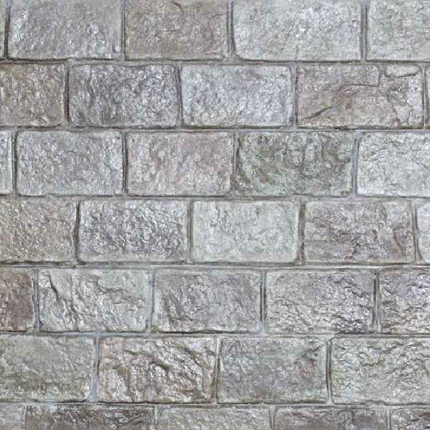

**Old Cobblestone**

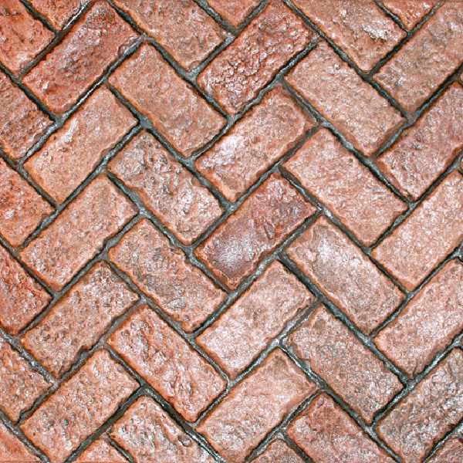

**Herringbone Old Cobblestone**

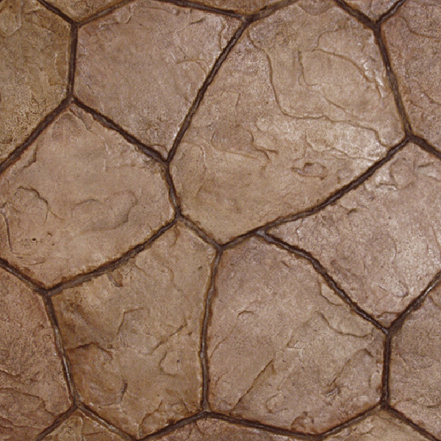

**Random Sandstone Hammered Edge Stone**

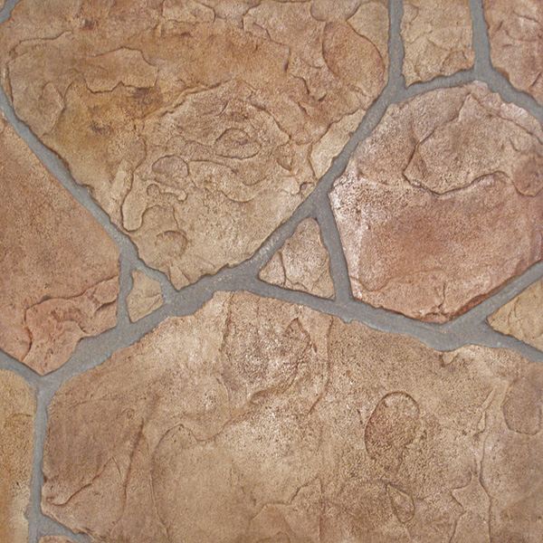

**Arizona Flagstone**

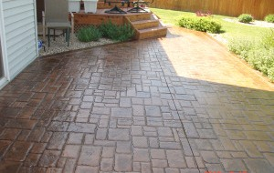

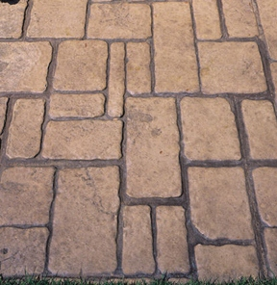

**Random Interlocking Cobblestone**

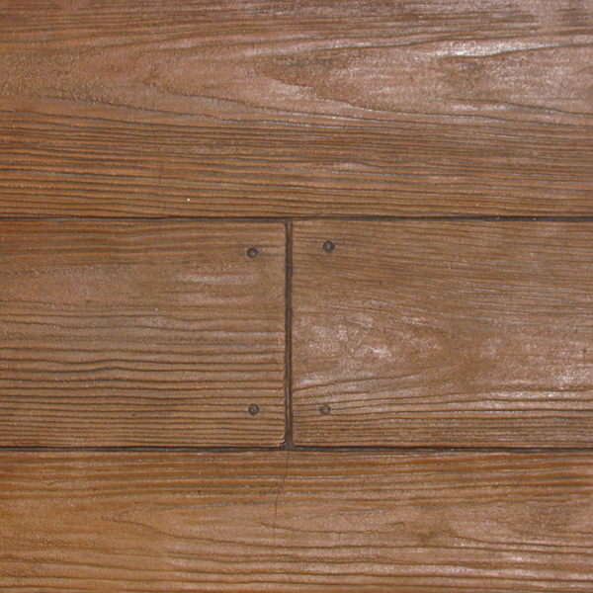

**Boardwalk Wood Plank 12” x 6’**

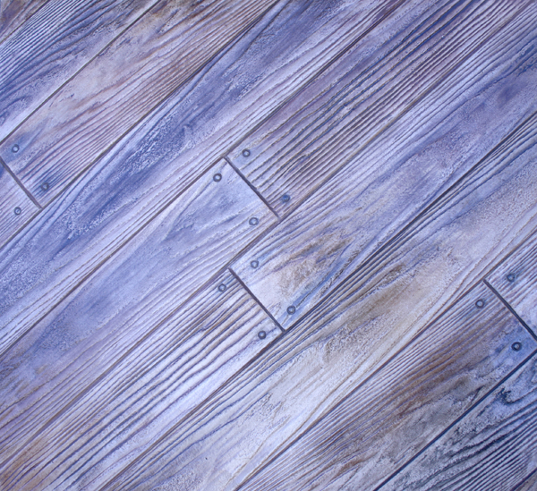

**Random Boardwalk 6” Wood Plank**

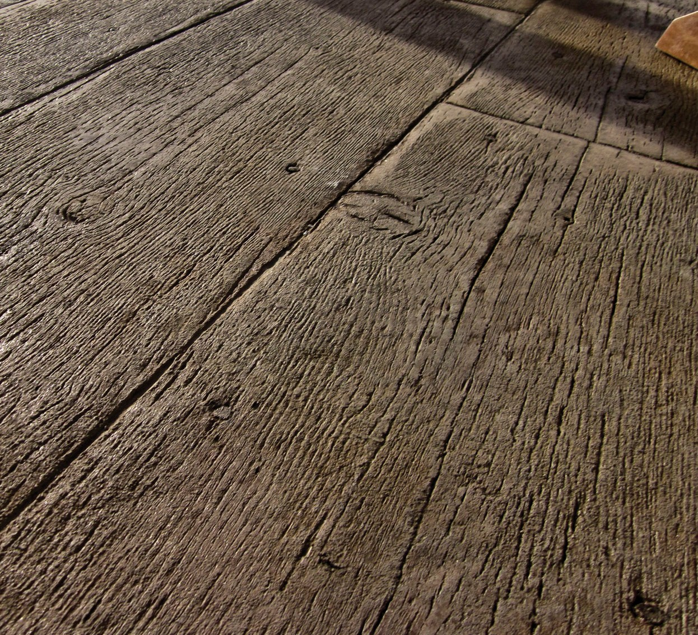

**Gilpin’s Falls Bridge Plank**

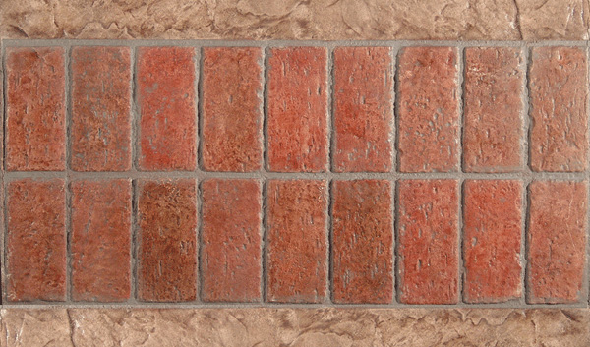

**Double Soldier Course Band**

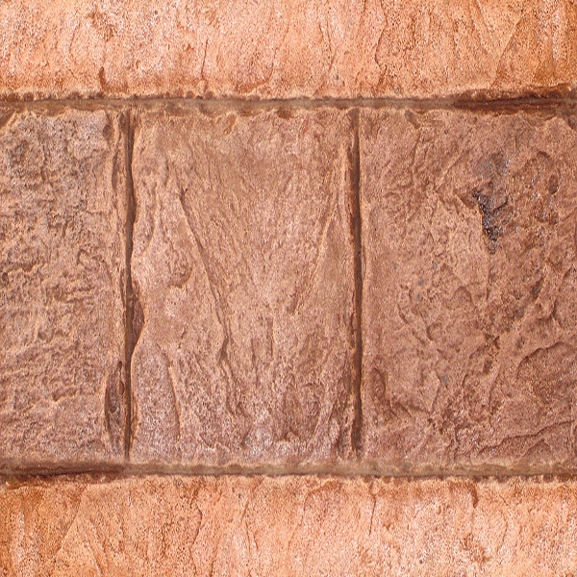

**12” x 12” Belgium Slate Tile Band**